SWECC004 GIS work process – campus trees and green spaces
Nov 2, 2026 · @Nālani

1. Work process
We mapped the trees, paths and green spaces of the central campus park on 29 October 2026 with a phone GPS, then cleaned the data and built point, line and polygon layers in RD New.

Theme and study area
- Theme: campus trees and green spaces.
- Study area: the central park of Wageningen Campus, between the Forum, Orion and Atlas buildings. The survey covers about 370 × 317 m (RD x 173 996–174 366, y 444 007–444 323).
- Outside the plan: g02 (gravel), g07 (unmowed trees/shrubs) and path4 lie south-west of the planned area. They are included in the study area, and so are trees t01–t03 that stand in them.

Information model
Object | Geometry | IDs | Attributes
Tree | Point | t01–t16 | GPS time, species, height (m), DBH (cm), circumference (cm, derived), photo, QA note
Path | Line | path1–path4 | recording start/end, length (m), outside planned area (yes/no)
Green space | Polygon | g01–g07 | label (pond, gravel, mowed…), area (m²), perimeter (m), outside planned area (yes/no)

Field method
- GPS app: Open GPX Tracker on an iPhone, one GPX file per object, on 29 October 2026 (times in local time, CET).
- Trees (points): a waypoint at the foot of each tree, 12:12–14:31, named t01–t16.
- Paths (lines): walked as tracks with one point every ~2 s, 12:11–12:26, files path1–path4.
- Green spaces (polygons): each boundary walked once as a closed track (~1 point/s), 14:35–15:14, files g01–g07.
- Tree measurements: the Arboreal app measured each tree's height and its diameter at breast height (DBH, at 1.3 m) and took a photo, at the same time as the GPS waypoint.
- Circumference: not measured with a tape; it is calculated from the diameter as C = π × DBH.
- Crown width: Arboreal's crown fields are empty for all 16 trees, so crown width was not recorded.

Processing
The ArcGIS tool chain and what each step does:
- GPX To Features: reads the waypoints and track points of each GPX file (WGS84).
- Project to RD New (EPSG:28992): puts all layers in metres in the Dutch grid.
- Points To Line: joins each path's track points in time order into one line.
- Feature To Polygon: closes each boundary track into one polygon.
- Add attributes: IDs and labels from the file names; the Arboreal table joined to the tree points on ID (T01 → t01).
- Calculate Geometry: area and perimeter of each polygon, length of each path, x/y of each tree, all in RD New.
The delivered datasets were built by a script (build_gis_map.py, GDAL/Python) that runs these same steps, and they were exported to a file geodatabase for ArcGIS. The Arboreal join was checked twice: recording time (within 3 min) and position (each Arboreal tree lies nearest to the GPS point with the same ID).

Data cleaning
What | Where | Action
GPS glitch: 2 points at 13:39:57 UTC jumping 33.5 m and 20.5 m | g01 pond | deleted, plus 1 back-step point that then made the outline cross itself
Walk detours onto the bridge where path1 crosses the pond | g01 pond | 18 points deleted; edge runs straight across both bridge ends
Start-of-walk lobe and corner at the south-east of the pond | g01 pond | 32 points deleted; east edge runs straight from finish point to waypoint v05
Stray waypoint "2:56:04 PM" (accidental tap, ~150 m south of the lawn) | g03 | deleted
147 track points (with GPS wobble near the Forum) | trees file | deleted; only waypoints t01–t16 kept
Typo "Lach" in the species name | tree t05 | corrected to "Larch"
Every deleted point is listed in removed_points_log.csv.

2. Datasets
There are three data layers, a point, a line and a polygon layer, plus the survey extent, all in Amersfoort / RD New (EPSG:28992), in swecc004_field_map.gdb and .gpkg.
Layer | Geometry | Features | Coordinate system
trees | Point | 16 | RD New (EPSG:28992)
paths | Line | 4 | RD New (EPSG:28992)
habitat_polygons | Polygon | 7 | RD New (EPSG:28992)
study_area_extent | Polygon | 1 | RD New (EPSG:28992)

trees (point)
Field | Meaning
id | tree ID, t01–t16
time | GPS waypoint time (UTC)
ele_gps_m | GPS elevation (m), unreliable
x_rd, y_rd | position in RD New (m)
in_polygon | green space the tree stands in (empty = none)
species | tree species (Arboreal)
height_m | tree height (m)
dbh_cm | diameter at breast height (cm)
circumference_cm | circumference (cm), π × DBH
breast_height_m | height of the diameter measurement (1.3 m)
inclination_deg | lean of the trunk (°)
arboreal_time_local | time of the Arboreal measurement (CET)
arboreal_accuracy_m | Arboreal's GPS accuracy (m)
arboreal_lat, arboreal_lon | Arboreal's tree position (WGS84)
offset_arboreal_m | distance between Arboreal position and GPS waypoint (m)
photo | photo file of the tree
qa_note | quality note (t05, t07)

paths (line)
Field | Meaning
id | path ID, path1–path4
source_file | GPX file it came from
n_vertices | number of track points
t_start, t_end | start and end of the walk (UTC)
outside_planned_area | yes for path4
length_m | length in RD New (m)

habitat_polygons (polygon)
Field | Meaning
id | green-space ID, g01–g07
label | description from the file name (pond, gravel, mostly mowed, Orion, unmowed shrubs, Atlas unmowed, unmowed trees/shrubs)
source_file | GPX file it came from
n_vertices | number of vertices after cleaning
t_start, t_end | start and end of the walk (UTC)
outside_planned_area | yes for g02 and g07
area_m2 | area in RD New (m²)
perimeter_m | perimeter in RD New (m)

Metadata
Item | Value
Date of fieldwork | 29 October 2026, 12:11–15:14 CET
Devices and apps | iPhone with Open GPX Tracker (GPS tracks and waypoints); Arboreal app (height, DBH, photo)
Estimated accuracy | about 3–5 m (phone GPS); Arboreal reports 2.8–6 m per tree, except t05 (20.8 m) and t15 (14.8 m)
Collected by | [names of the group members]
Processing | script build_gis_map.py; cleaning log removed_points_log.csv
Open point: fill in who collected the data and the iPhone model.

3. Graphs and tables
The 16 trees are 13 species, and most green-space area is unmowed grass or shrubs. The tables below are excerpts of the attribute tables.

Attribute table: trees (selected fields)
id | species | height_m | dbh_cm | circumference_cm | in_polygon
t01 | Norway maple | 10.6 | 19.1 | 60.0 | g02
t02 | Silver birch | 7.4 | 13.2 | 41.5 | g02
t03 | Wild cherry | 11.3 | 42.9 | 134.8 | g07
t04 | Salix x sepulcralis (willow) | 13.7 | 41.8 | 131.3
t05 | Larch (Larix spec.) | 8.8 | 30.5 | 95.8
t06 | Weeping willow | 17.2 | 76.5 | 240.3
t07 | Silver birch | 38.1 | 30.7 | 96.4
t08 | Hawthorn | 14.3 | 32.1 | 100.8
t09 | Ash | 5.0 | 5.7 | 17.9
t10 | Sweet gum | 7.8 | 25.2 | 79.2 | g03
t11 | Ash | 12.9 | 22.8 | 71.6 | g06
t12 | Caucasian wingnut | 11.2 | 43.3 | 136.0 | g06
t13 | Bald cypress | 9.6 | 32.5 | 102.1 | g06
t14 | Cotoneaster | 3.9 | 5.6 | 17.6
t15 | Basswood | 6.3 | 12.0 | 37.7
t16 | Basswood | 8.0 | 13.4 | 42.1 | g03
The height of t07 (38.1 m) is implausible for a silver birch with a 30.7 cm trunk and should be re-measured.

Attribute table: habitat_polygons
id | label | n_vertices | perimeter_m | outside_planned_area
g01 | pond | 114 | 417.2 | no
g02 | gravel | 78 | 227.5 | yes
g03 | mostly mowed | 104 | 370.3 | no
g04 | Orion | 107 | 369.1 | no
g05 | unmowed shrubs | 111 | 381.5 | no
g06 | Atlas, unmowed | 117 | 416.4 | no
g07 | unmowed trees/shrubs | 57 | 184.7 | yes

Attribute table: paths
id | length_m | n_vertices | walked (CET) | outside_planned_area
path1 | 294.2 | 96 | 12:11–12:14 | no
path2 | 100.4 | 37 | 12:17–12:18 | no
path3 | 280.2 | 104 | 12:19–12:23 | no
path4 | 191.6 | 68 | 12:24–12:26 | yes
Path length per surface type cannot be shown: the surface (paved, gravel, grass) was not recorded for the paths. Open point: add a surface field to the paths layer.

Trunk circumference per species
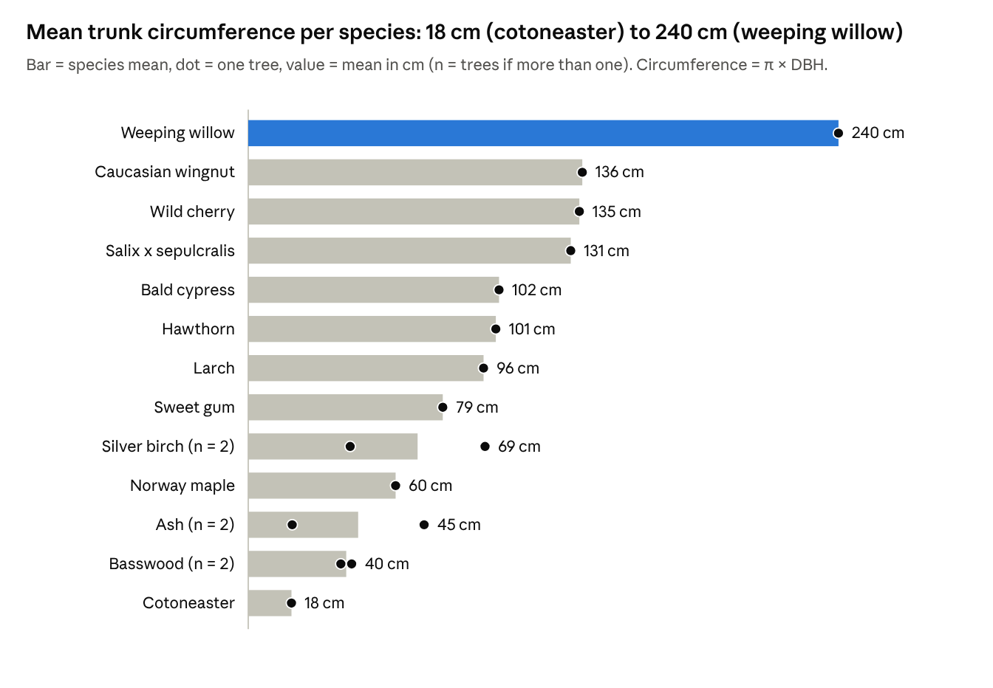
Arboreal measurements, 16 trees, 29 Oct 2026 · circumference derived from DBH
Only ash, silver birch and basswood have two trees each; all other species are single trees, so their "mean" is one measurement.

Green-space area per type
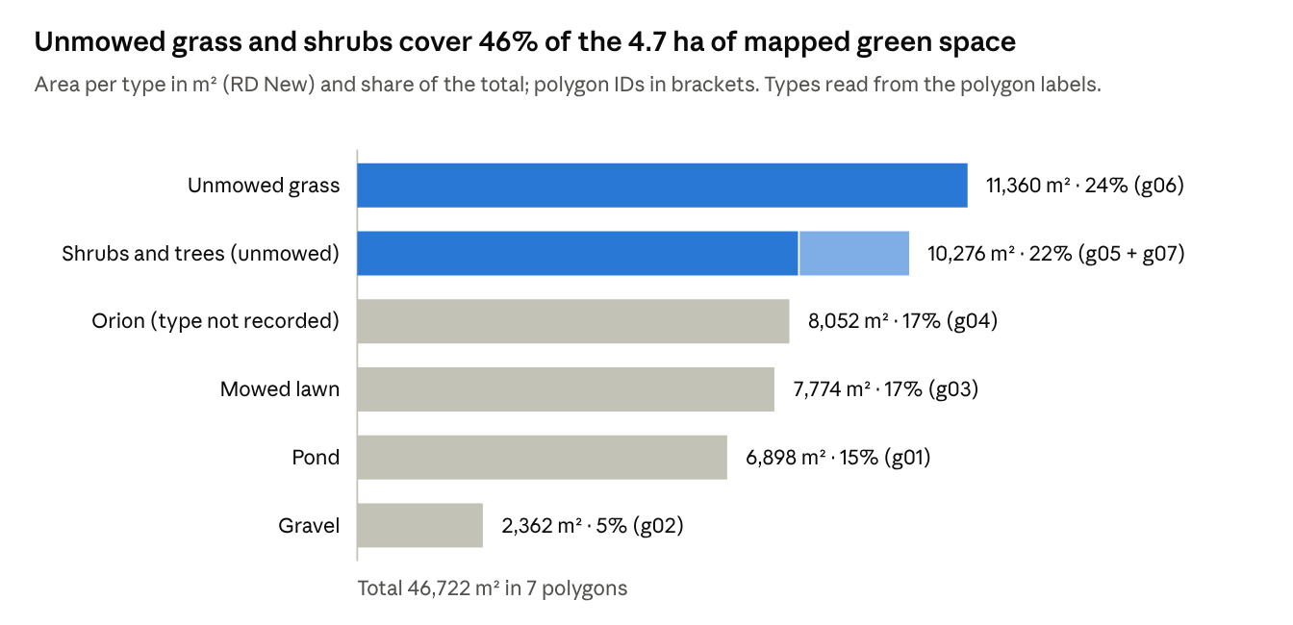
habitat_polygons, areas from Calculate Geometry in RD New · type grouping from the polygon labels
The type of g04 ("Orion") was not recorded in the field; open point: check whether it is lawn or meadow and add a type field to the polygons.

Map
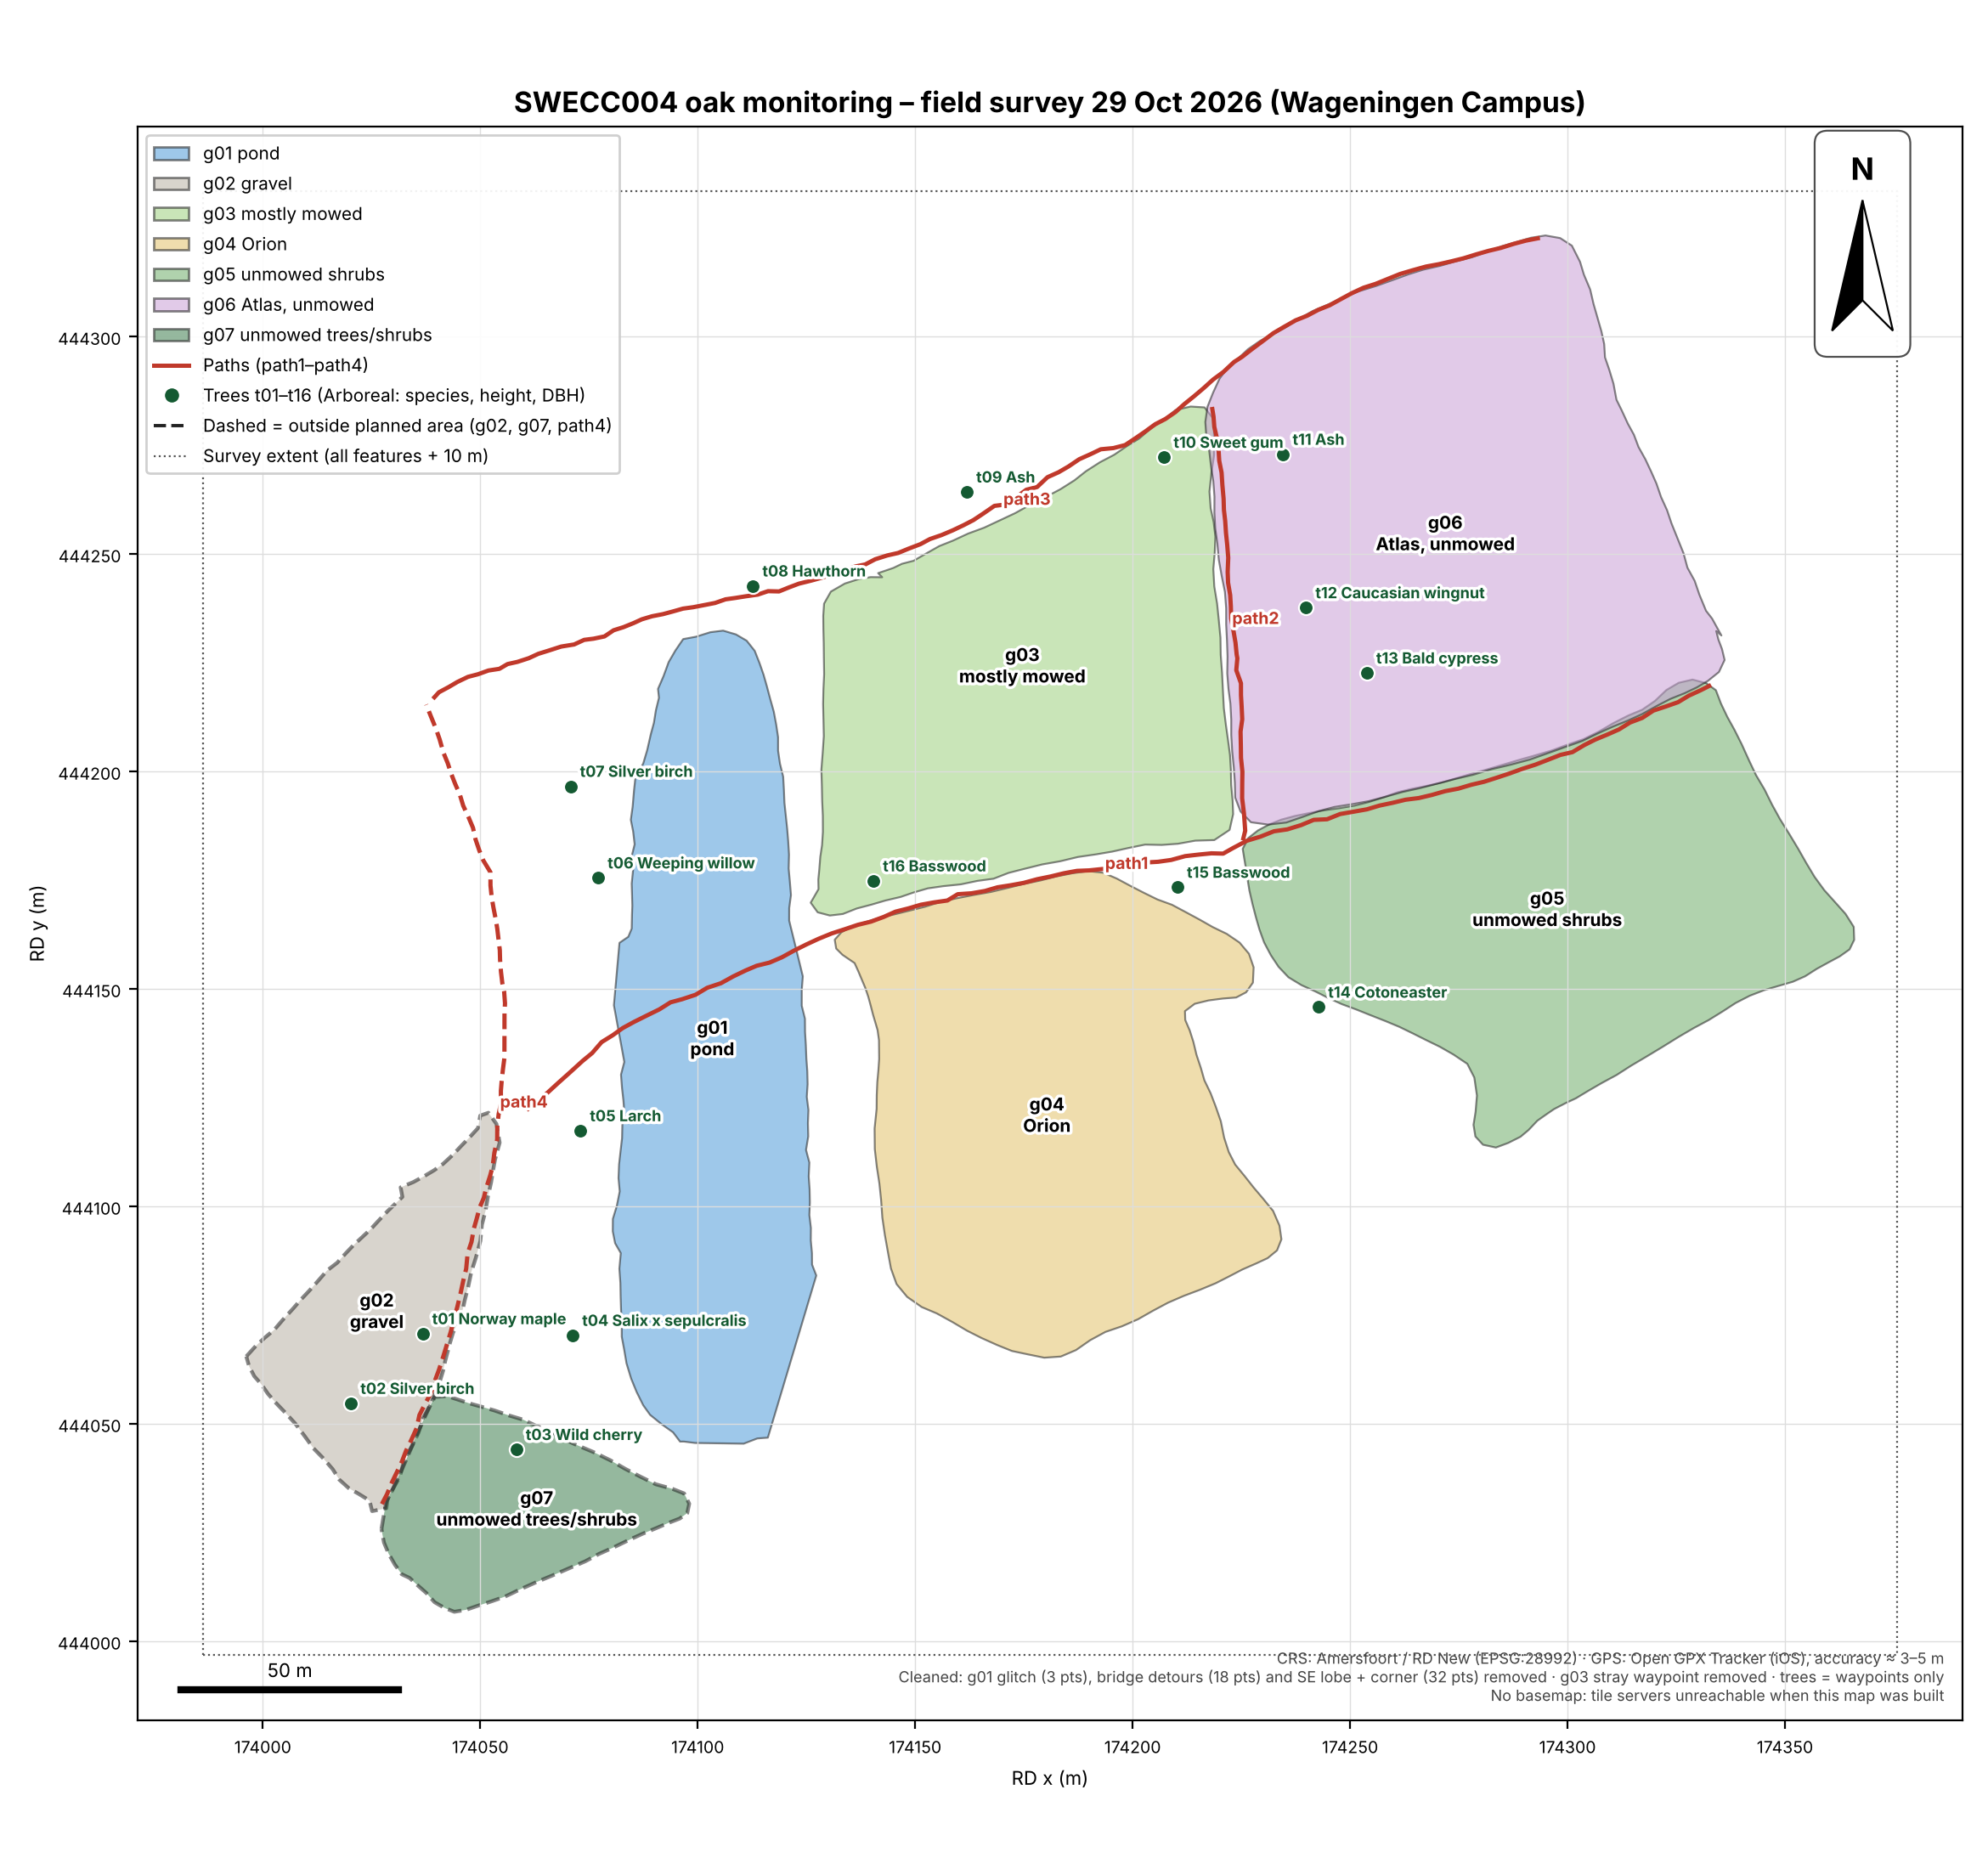
The map shows the cleaned layers in RD New with a north arrow, a 50 m scale bar and a legend. It has no basemap, because the map servers were not reachable when it was built; the ArcGIS and QGIS projects add an aerial photo.

Open points
- ☐ Fill in who collected the data and the iPhone model (Metadata).
- ☐ Re-measure the height of t07 (38.1 m recorded).
- ☐ Record the surface type of path1–path4, so path length per surface can be shown.
- ☐ Record the green-space type of g04 (Orion).
- ☐ Decide whether t04 (Salix x sepulcralis) and t06 (weeping willow) should use one species name.

